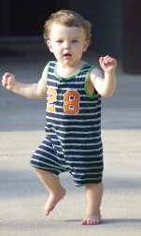
Baby Steps
Slow down and describe the action in an important moment step by step.
*If you were the director of a film, this might be a time when you would use slow motion.
*If you are illustrating a picture book or graphic story, you might show the action in multiple small frames.
EXAMPLE:
“She opened the door.” could be written:
“She grasped the cold doorknob and turned it gently to the right. She nudged the door inward. The hinges creaked. Her shoe squeaked across the polished floor.

