Exploding the Moment
Write a long, descriptive snapshot. Use your zoom lens to focus on details. Include sounds, smells, or tastes. Remember, even the air can have a taste. You can specifically describe the sensory details as well as the character’s reaction.

*If you are writing a picture book or graphic story, include an illustration that is zoomed in on details of a scene or object.

*If you are writing a film script, where would the director focus?

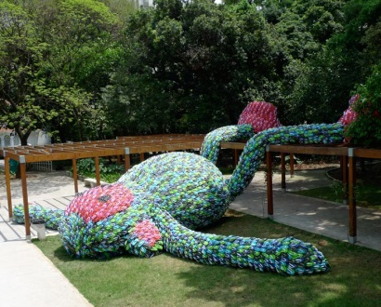
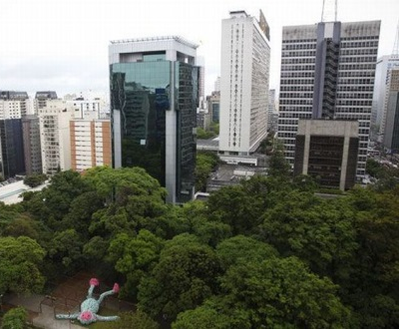

Macaco Gordo (Fat Monkey)

