Rorschach Test
Number your page 1-4. Next to each number, write what you see in the picture.
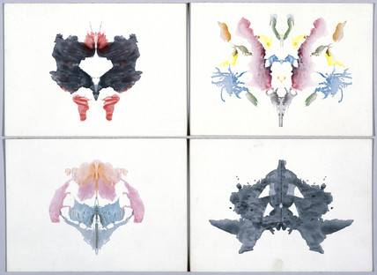
4
3
2
1
Common Responses:
- bat, butterfly, moth, mask
- unidentifiable animal; face
- crab, lobster, spider
- two people with their hands touching; dog, elephant, bear (some four-legged animal)

