Thoughtshots

Thoughtshots are the reflections, feelings, and opinions of the character. They can be revealed through inner dialogue or comments from the narrator. A thoughtshot allows the audience to pause with the character and think about a particular event or detail along with the character. This can lend insight into the fictional world of the story as well as the real world.

EXAMPLE:
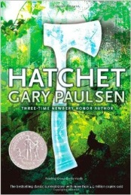
He was stopped. Inside he was stopped. He could not think past what he saw, what he felt. All was stopped. The very core him, the very center of Brian Robeson was stopped and stricken with a white-flash of horror, a terror so intense that his breathing, his thinking, and nearly his heart had stopped.
Seconds passed, seconds that became all of his life, and he began to know what he was seeing, began to understand what he saw and that was worse, so much worse that he wanted to make his mind freeze again.
Paulsen, Gary. Hatchet. New York City: Simon & Schuster, 1987. Print.

