NAME: ____________________________________
UIL Team/Coach: ____________________________

WEST RIDGE MIDDLE SCHOOL
UIL T-Shirt
ORDER FORM
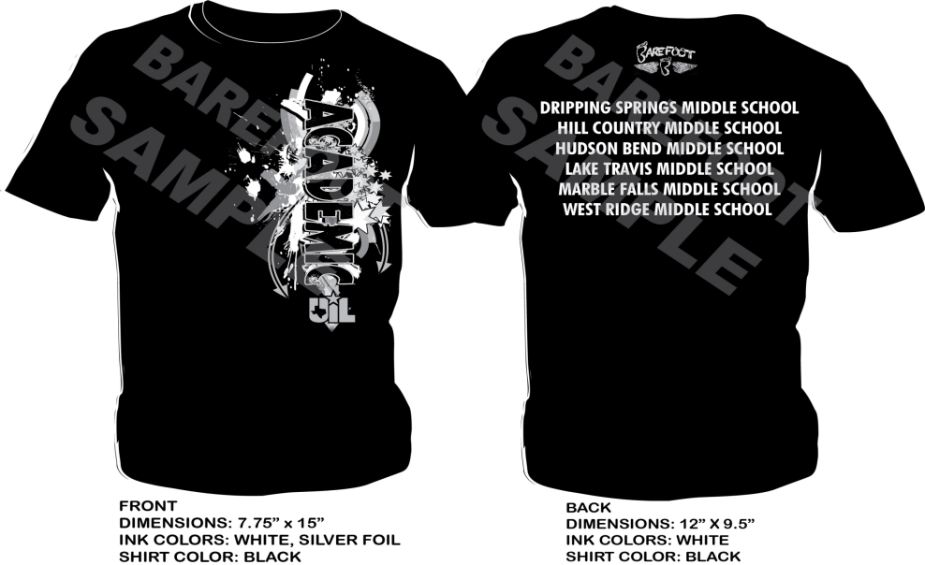

SHORT SLEEVE T-SHIRT SIZES NEEDED(shirt color GREEN)

___ ___ ___ ___ ___ ____ ___
YM YL AS AM AL AXL AXXL @ $10.00 = ________

**Please include cash or checks made out to WRMS when returning this form to your UIL coach. All shirt order forms and money are due by FEB 7by 4pm. **

